

FACULTY OF TECHNOLOGY AND ENGINEERING
DEVANG PATEL INSTITUTE OF ADVANCED TECHNOLOGY AND RESEARCH

DEPARTMENT OF INFORMATION TECHNOLOGY

A.Y 2026-27 Semester-3

LAB MANUAL

CSUC201: Fundamentals of Data Structure and Algorithms



Practical 2
Practical AIM:
To implement linear and binary search using both iterative and recursive approaches.
Practical 2.1
Problem Definition:
A security guard at a parking lot checks vehicles one by one from the entrance to find a car with a specific license plate. Sometimes he starts from the entrance, sometimes he calls a helper who starts from where the guard left off. Given a list of license plates and a target plate, implement both approaches — one that checks plates one by one from the start, and one where the function calls itself to continue checking — and report the position of the target plate if found.
Describe the approach you used. What happens in your solution if the target plate appears more than once in the list? Does it find the first occurrence, the last, or just any one?
Problem faced:
I had difficulty understanding linear search and the difference between iterative and recursive search. I was also confused about why -1 is returned.
Solution:
I learned that linear search checks elements one by one. Iterative search uses a loop, while recursive search calls the function again. I understood that -1 means the element was not found.
Output:
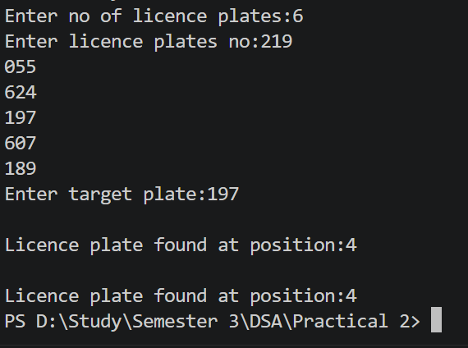
Practical 2.2
Problem Definition:
A librarian maintains a sorted catalog of book codes and needs to locate a specific code quickly. Instead of going through every book, she opens the catalog to the middle, checks whether the target is to the left or right, and repeats. Given a sorted list of book codes and a target code, implement both approaches — one using a loop and one where the function calls itself — and report the position of the target code.
Describe the approach you used. What is the one condition your input must satisfy for this approach to work correctly? What would go wrong if that condition was not met?
Problem faced:
I had difficulty understanding binary search and the use of low, high, and mid.
Solution:
I learned that binary search checks the middle element first and then searches the left or right side. I also understood that recursive search calls the function again. The array must be sorted for binary search.
Output:
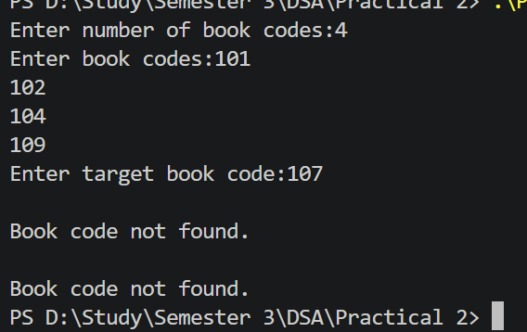
Key Questions:
1. [Problem 1] If the target plate appears near the end of a very long list, your solution stillchecks every plate before it. Can you think of any property the input would need to have for you to skip checking some plates entirely? What does Problem 2.2 tell you about this?
ANS:
Linear search checks every plate because it does not know where the target might be. To skip some plates, the input would need to have a sorted order. If the plates are sorted, we can use binary search instead of linear search. Binary search checks the middle element first and eliminates half of the list each time. Problem 2.2 tells us that binary search requires the list to be sorted. Therefore, sorting allows us to search more efficiently.

2. [Problem 2] What is the consequence of applying your solution to a list that is not sorted? Would it always give a wrong answer, or only sometimes? Explain your reasoning without running any example.
ANS:
Binary search does not work correctly on an unsorted list because it decides which half to search based on the order of elements. If the list is not sorted, the comparison with the middle element may lead us to the wrong half. As a result, the target may be skipped even if it exists in the list.
It will not always give a wrong answer by chance. Sometimes it may still find the target, but there is no guarantee. Therefore, the list must be sorted before applying binary search.

GitHub Link:
https://github.com/dhanvi-219/FDSA/tree/main/Practical%202

